Fall 2021 Chemistry Final A

Choose the best answer to each of the following questions. (2 pt. each)

- Which is the smallest particle inside of an atom?
  - Nucleus
  - Proton
  - Neutron
  - Electron

- Which particle has a negative charge?
  - Nucleus
  - Proton
  - Neutron
  - Electron

- Given the following atom, ⁸⁰₃₅ Br, what does the number 80 represent?
  - Atomic number
  - Mass number
  - Oxidation number
  - Average atomic mass

- How many neutrons are in ⁹²Zr?
  - 40
  - 51
  - 52
  - 92

- How many electrons are in Sc⁺?
  - 20
  - 21
  - 22
  - 25

- How many protons are in ⁵⁸Fe?
  - 26
  - 28
  - 32
  - 58

- Isotopes of different elements must have different:
  - Atomic numbers
  - Oxidation numbers
  - Mass numbers
  - Numbers of valence electrons

- Based on the Bohr model of Hydrogen, what type of energy is released if electrons move from n=5 to n=3?
  - Infrared light
  - Ultraviolet light
  - Visible light—blue
  - Visible light—red

- Which form of electromagnetic radiation has the highest frequency?
  - Infrared radiation
  - Visible light
  - Radio waves
  - Gamma rays

- Which element has the electron configuration: 1s²2s²2p⁶3s²3p¹?
  - Lithium
  - Sodium
  - Potassium
  - Magnesium

- Which element has the electron configuration: [Xe] 6s²4f ³?
  - Lanthanum
  - Cerium
  - Praseodymium
  - Tantalum

- What isotope is needed to make this nuclear equation true?
²³⁸U ²³⁴Th + _____
  - Alpha particle
  - Beta particle
  - Gamma particle
  - Neutron

- Bismuth-212 has a half-life of roughly 61 minutes. If you have a 200-gram sample of ²¹²Bi and you leave it on the counter for 305 minutes, how much of your sample would be left?
  - 0 grams
  - 3.125 grams
  - 6.25 grams
  - 12.5 grams

- Which type of nuclear reaction can be seen in the equation below?
²²⁶Ra ²²²Rn + α
  - Alpha decay
  - Beta decay
  - Nuclear fusion
  - Nuclear fission
- Which element is most likely to become an anion?
  - Magnesium
  - Aluminum
  - Helium
  - Nitrogen

- Based on its electron configuration, which element is most likely stable?
  - Phosphorus
  - Neon
  - Sulfur
  - Silver

- Based on this electron configuration, [Kr] 5s²4d⁷, how many valence electrons does this element have?
  - 2
  - 4
  - 5
  - 7

- What is the oxidation number of Calcium when it becomes an ion?
  - 1+
  - 2+
  - 2-
  - 1-

- Which diatomic molecule is held together by a double covalent bond?
  - F₂
  - O₂
  - N₂
  - H₂

- Which intermolecular force is the strongest?
  - Triple covalent bond
  - Ionic bond
  - Hydrogen bond
  - Van der Waals force

- Which compound is an ionic compound?
  - C₆H₁₂O₆
  - P₂O₅
  - Ca(OH)₂
  - NH₃

- Which is the name of N₂O₅?
  - Nitrogen oxide
  - Nitrogen pentoxide
  - Dinitrogen pentoxide
  - Nitrogen (V) oxide

- What is the formula for ammonium bromide?
  - NH₄Br
  - NHBr₄
  - NH₄Br₄
  - NH₃Br

- Which is the VSEPR shape of the molecule CO₂?
  - Linear
  - Bent
  - Trigonal planar
  - tetrahedral

- Which molecule is polar?
  - CO₂
  - BCl₃
  - SiF₄
  - H₂O

- Which elements in each set are in the same family?
  - Ru, Ag, Cd, Rh
  - N, P, As, Sb
  - F, S, Sn, Zn
  - Y, Zr, Nb, Mo

- Which element is an alkali metal?
  - Iodine
  - Oxygen
  - Zinc
  - Potassium

- Based on periodic trends, which element in this set has the lowest first ionization energy?
  - Aluminum
  - Francium
  - Fluorine
  - Phosphorus

- During a few chemical reactions, these salts were formed. Which of them would be considered a precipitate and would NOT make an aqueous solution?
  - MgO
  - Li₂CO₃
  - Fe(NO₃)₂
  - NaF

- A student suggested that oxygen gas was produced during a chemical reaction. Which observation could be made to provide evidence that oxygen gas was released by the reaction?
  - A smell was produced.
  - A color change occurred.
  - A nearby flame increased in size.
  - A nearby flame was extinguished.

- What type of reaction is represented by the equation below?
CaCO₃ CaO + CO₂

  - Synthesis
  - Decomposition
  - Single replacement
  - Double replacement

- Which single replacement reaction can occur?
  - 3LiCl + Fe FeCl₃ + 3Li
  - Ca(OH)₂ + Mg Mg(OH)₂ + Ca
  - H₂O + Sr Sr(OH)₂ + H₂
  - MgF₂ + Cl₂ MgCl₂ + F₂

- Which equation shows a neutralization reaction?
  - 2KCl + Na₂O K₂O + 2NaCl
  - H₂SO₄ + Mg(OH)₂ MgSO₄ + 2H₂O
  - 2AgNO₃ + FeS Ag₂S + Fe(NO₃)₂
  - NaClO₃ + KMnO₄ NaMnO₄ + KClO₃

- Which can be the (unbalanced) products of the following reaction?
C₄H₁₀ + O₂ ???

  - C + H₂O
  - CO₂ + H₂O
  - C₆H₁₂O₆
  - CO₂ + H₂

- Which is a balanced equation?
  - 3NH₃ 3N₂ + H₂
  - 2H₂O₂ 2H₂O + O₂
  - 3Ag₂CO₃ 3Ag₂O + CO₂
  - KNO₃ + FeI₄ 4 KI + Fe(NO₃)₄

- Look at the following equation: Fe₂(SO₄)₃ + 3Cr 3CrSO₄ + 2Fe. If you have 3.0 moles of Fe₂(SO₄)₃, how many moles of CrSO₄ can be produced?
  - 1.0 mole
  - 3.0 moles
  - 6.0 moles
  - 9.0 moles

- Using the same equation from #36, if you have 104.5 grams of Cr, how many atoms of Fe can be produced by the reaction?
  - 6.123 x 10²³ atoms
  - 8.067 x 10²³ atoms
  - 1.227 x 10²⁴ atoms
  - 2.198 x 10²⁴ atoms

- Given the equation, C₇H₁₆ + 11O₂ 7CO₂ + 8H₂O, if you use 6.0 moles of O₂ in the reaction, how many liters of CO₂ would be produced at STP?
  - 24 L
  - 56 L
  - 75 L
  - 86 L

- What is the empirical formula of a compound that contains 69.9% Fe and 30.1% O?
  - FeO
  - Fe₂O
  - Fe₂O₃
  - Fe₃O₂

- The empirical formula of a chemical is N₂O₅. The molecular mass of the chemical is 216 grams/mole. What is the molecular formula of the chemical?
  - N₂O₅
  - N₄O₁₀
  - N₆O₁₅
  - N₈O₁₅

- What is the percent composition of water in the following hydrate: MgSO₄*7H₂O?
  - 51.2%
  - 57.6%
  - 62.1%
  - 68.9%

- What does it mean to say that set of reversible reactions is at equilibrium?
  - The rates of forward and backward reactions are the same.
  - The masses of reactants and products in the two reactions are the same.
  - The concentrations of the reactants and products in the two reactions are the same.
  - The volumes of the reactants and products in the two reactions are the same.

- What is the equilibrium constant in the following reaction AND which side of the reaction is favored?
N_{2 (g)} + 3H_{2 (g)} 2NH_{3 (g)}
[N₂] = 0.0375 M
[H₂] = 0.0625 M
[NH₃] = 0.0500 M

- 0.00366; reactants favored
- 0.00366; products favored
- 273; reactants favored
- 273; products favored

- Using the same equation from #43, if we assume that we are at equilibrium, what happens if pressure is increased on the system?
  - Reactants are favored and more N₂ will be produced.
  - Reactants are favored and more NH₃ will be produced.
  - Products are favored and more H₂ will be produced.
  - Products are favored and more NH₃ will be produced.

- Which of the chemicals below is an acid?
  - H₂O
  - NaOH
  - HNO₃
  - NH₃

- What is a characteristic of a chemical known as a base?
  - pH less than 7
  - sour to taste
  - slippery to the touch
  - releases H+ ions in a solution

- What is the pH of a chemical that has a [H+] = 1 x 10⁻⁸ M?
  - pH = 6; The chemical is an acid.
  - pH = 6; The chemical is a base.
  - pH = 8; The chemical is an acid.
  - pH = 8; The chemical is a base.

- You mix 68.95 grams of NaOH in 2.5 liters of water. What is the molarity of your solution?
  - 0.69 M
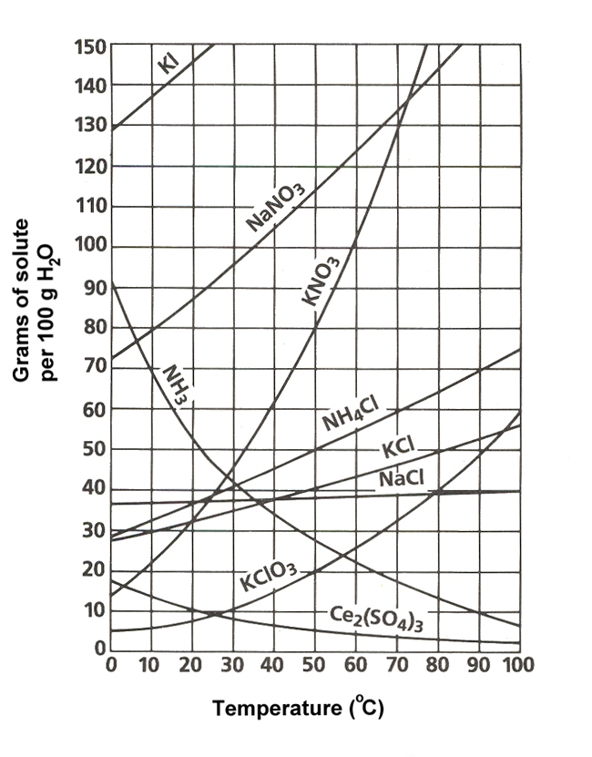
  - 0.74 M
  - 0.88 M
  - 1.2 M

- Look at the solubility curves on the right. If you wanted to make a saturated solution in 100 grams of water using NH₄Cl at 70 degrees C, how much of the salt would you need to add?
  - 50 grams
  - 60 grams
  - 65 grams
  - 80 grams

- In your Chemistry class, you were asked to perform a titration to determine the molarity of an unknown acid. You were given 15.0 mL of acid as well as a 0.20 M NaOH solution. When you ran the titration, you used 37 mL of the base. What was the molarity of your mystery acid?
  - 0.25 M
  - 0.33 M
  - 0.49 M
  - 0.67 M

