Fall 2021 Chemistry Final B

Choose the best answer to each of the following questions. (2 pt. each)

- Which is the largest particle inside an atom?
  - Nucleus
  - Proton
  - Neutron
  - Electron

- Which particle has no charge?
  - Nucleus
  - Proton
  - Neutron
  - Electron

- Given the following atom, ¹¹⁹₅₀ Sn, what does the number 50 represent?
  - Atomic number
  - Mass number
  - Oxidation number
  - Average atomic mass

- How many protons are in ⁷¹Ga?
  - 31
  - 32
  - 70
  - 71

- How many neutrons are in ¹¹⁰Ag?
  - 47
  - 61
  - 63
  - 110

- How many electrons are in S²⁻?
  - 6
  - 14
  - 16
  - 18

- Compared to an atom, ions have a different:
  - Number of protons
  - Number of electrons
  - Number of neutrons
  - Mass number

- Based on the Bohr model of Hydrogen, what type of energy is released if electrons move from n=4 to n=2?
  - Infrared light
  - Ultraviolet light
  - Visible light—blue
  - Visible light—red

- Which form of electromagnetic radiation has the lowest frequency?
  - Radio waves
  - Gamma rays
  - Infrared radiation
  - Visible light

- Which element has the electron configuration: 1s²2s²2p⁶3s²3p⁴?
  - Silicon
  - Sulfur
  - Oxygen
  - Selenium

- Which element has the electron configuration: [Rn] 7s²5f ¹⁴ 6d⁵?
  - Tantalum
  - Bohrium
  - Hassium
  - Dubnium

- What isotope is needed to make this nuclear equation true?
⁹⁰Sr β + _____

  - Yttrium-89
  - Yttrium-90
  - Krypton-88
  - Rubidium-88

- Cesium-137 has a half-life of 30 years. If your 400-gram sample sits in the laboratory for the next 120 years, how much will be left for those chemists to use?
  - 0 grams
  - 25 grams
  - 50 grams
  - 200 grams

- Which type of nuclear reaction can be seen in the equation below?
²³⁵U + ¹n ¹⁴⁴Ba + ⁸⁹Kr + 3 ¹n
  - Alpha decay
  - Beta decay
  - Nuclear fusion
  - Nuclear fission
- Which element would most likely become a cation?
  - Xenon
  - Oxygen
  - Lithium
  - Carbon

- Based on its electron configuration, which element is most likely stable?
  - Argon
  - Calcium
  - Chlorine
  - Silicon

- Based on this electron configuration, [Xe] 6s²4f¹⁴5d¹⁰6p³, how many valence electrons does this element have?
  - 2
  - 3
  - 5
  - 10

- What is the oxidation number of Phosphorus when it becomes an ion?
  - 1-
  - 3-
  - 3+
  - 1+

- Which diatomic molecule is held together by a double bond?
  - N₂
  - I₂
  - F₂
  - O₂

- Which intermolecular force is the weakest?
  - Single covalent bond
  - London dispersion force
  - Van der waals force
  - Ionic bond

- Which compound is a covalent compound?
  - NaCl
  - H₂O
  - Li₂SO₄
  - KOH

- Which is the name of Fe(NO₃)₃?
  - Iron nitrate
  - Iron (III) nitrate
  - Iron trinitrate
  - Iron (III) trinitrate

- What is the formula for sodium carbonate?
  - Na₄C
  - NaCO₃
  - Na₂CO₃
  - SCO₃

- Which is the VSEPR shape of the molecule BF₃?
  - Trigonal planar
  - Trigonal pyramid
  - Tetrahedral
  - bent

- Which molecule is nonpolar?
  - H₂O
  - NH₂Cl
  - CCl₄
  - SF₂

- Which elements in each set are in the same period?
  - H, Li, Na, K
  - Ag, Au, Tc, W
  - C, N, O, F
  - U, Ce, Pm, Ta

- Which element is a halogen?
  - Lithium
  - Calcium
  - Chlorine
  - Xenon

- Based on periodic trends, which element in this set is the most electronegative?
  - Fluorine
  - Oxygen
  - Magnesium
  - Francium

- During a few chemical reactions, these salts were formed. Which of them would be considered a precipitate and would NOT make an aqueous solution?
  - NaOH
  - BaCl₂
  - AgNO₃
  - MgCO₃

- A student suggested that oxygen gas was produced during a chemical reaction. Which observation could be made to provide evidence that oxygen gas was released by the reaction?
  - A nearby flame increased in size.
  - A nearby flame was extinguished.
  - A smell was produced.
  - A bright light was produced.

- What type of reaction is represented by the equation below?
C₃H₈ + 5O₂ 3CO₂ + 4H₂O

  - Synthesis
  - Decomposition
  - Single Replacement
  - Combustion

- Which single replacement reaction can occur?
  - CaI₂ + Cl₂ CaCl₂ + I₂
  - 2Mn(CN)₅ + 5Zn 5Zn(CN)₂ + 2Mn
  - 2KOH + Co Co(OH)₂ + 2K
  - Al₂O₃ + 3Cd 3CdO + 2Al

- Which equation shows a neutralization reaction?
  - 2NaClO₃ + PbI₂ 2NaI + Pb(ClO₃)₂
  - KCl + LiC₂H₃O₂ KC₂H₃O₂ + LiCl
  - 3HNO₃ + Al(OH)₃ Al(NO₃)₃ + 3H₂O
  - SnF₂ + CuBr₂ SnBr₂ + CuF₂

- Which can be the (unbalanced) products of the following reaction?
MgHCO₃ ???

  - MgO + H₂O + CO₂
  - MgCO₃ + O₂
  - MgCO₃ + H₂O
  - Mg + HCO₃

- Which is a balanced equation?
  - Li₂O + CaCl₂ LiCl + 2CaO
  - 2FeCl₃ Fe + 3Cl₂
  - C₃H₈ + 5O₂ 3CO₂ + 8H₂O
  - K₂SO₄ + 2NaBrO₃ 2KBrO₃ + Na₂SO₄

- Look at the equation: Ag₃PO₄ + 3KI 3AgI + K₃PO₄. If you have 2.0 moles of KI, how many moles of K₃PO₄ could be produced?
  - 0.33 moles
  - 0.67 moles
  - 1.0 mole
  - 1.3 moles

- Using the same equation from #36, if you have 104.5 grams of KI, how many formula units (fus) of K₃PO₄ can be produced by the reaction?
  - 1.263 x 10²³ fus
  - 1.477 x 10²³ fus
  - 2.318 x 10²³ fus
  - 3.552 x 10²³ fus

- Given the equation, C₇H₁₆ + 11O₂ 7CO₂ + 8H₂O, if you use 6.0 moles of O₂ in the reaction, how many liters of H₂O would be produced at STP?
  - 54 L
  - 69 L
  - 98 L
  - 120 L

- What is the empirical formula of a compound that contains 43.6% P and 56.4% O?
  - PO₃
  - P₂O₃
  - P₂O₅
  - P₃O₆

- The empirical formula of a chemical is CH₂O. The molecular mass of the chemical is 120.1 grams/mole. What is the molecular formula of the chemical?
  - CH₂O
  - C₄H₈O₄
  - C₆H₁₂O₆
  - C₈H₁₆O₈

- What is the percent composition of water in the following hydrate: Na₂CO₃*10H₂O?
  - 47.1%
  - 50.9%
  - 53.4%
  - 63.0%

- Which has to be true for any system of reversible reactions at equilibrium?
  - K_{eq} > 1
  - K_{eq} < 1
  - K_{eq} = 1
  - K_{eq} = 0

- What is the equilibrium constant in the following reaction AND which side of the reaction is favored?
CO_{2(g)} + H₂O _{(l)} H₂CO_{3 (aq)}
[CO₂] = 0.0375 M
[H₂CO₃] = 0.0500 M

  - 0.750; Reactants are favored.
  - 0.750; Products are favored.
  - 1.33; Reactants are favored.
  - 1.33; Products are favored.

- Using the same equation from #43, if we assume that we are at equilibrium, and more H₂O is added to the system, what happens?
  - Reactants are favored and more CO₂ is made.
  - Reactants are favored and more H₂CO₃ is made.
  - Products are favored and more CO₂ is made.
  - Products are favored and more H₂CO₃ is made.

- Which of the chemicals below is a base?
  - HCl
  - NaOH
  - H₂O
  - H₃PO₄

- What is a characteristic of a chemical known as an acid?
  - reacts with metals
  - pH greater than 7
  - bitter to taste
  - releases OH- ions in a solution

- What is the pH of a chemical that has a [OH-] = 1 x 10⁻³ M?
  - pH = 3; The chemical is an acid.
  - pH = 3; The chemical is a base.
  - pH = 11; The chemical is an acid.
  - pH = 11; The chemical is a base.

- You mix 47.65 grams of CaCl₂ in 1.8 liters of water. What is the molarity of your solution?
  - 0.24 M
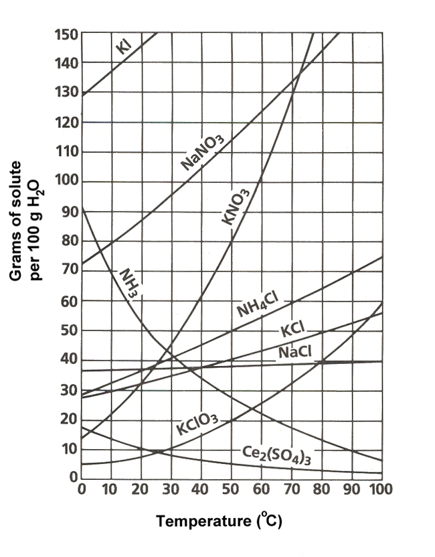
  - 0.33 M
  - 0.45 M
  - 0.67 M

- Look at the solubility curves on the right. If you wanted to make an unsaturated solution in 100 grams of water using KClO₃ at 70 degrees C, how much of the salt would you need to add?
  - 20 grams
  - 32 grams
  - 40 grams
  - 55 grams

- In your Chemistry class, you were asked to perform a titration to determine the molarity of an unknown acid. You were given 25.0 mL of acid as well as a 0.20 M NaOH solution. When you ran the titration, you used 86 mL of the base. What was the molarity of your mystery acid?
  - 0.45 M
  - 0.51 M
  - 0.69 M
  - 0.78 M

